2018 Cairns to Karumba Bike Ride

Dirt Ride Expression of Interest

In recent years the ‘Dirty Boys’ component of the Cairns to Karumba Bike Ride has grown enormously in popularity.
With the increased number of riders wishing to take part, ride organisers (Milboe Ltd) are keen to ensure that the logistics are sufficient to maintain the integrity of this wonderful riding experience, whilst also ensuring the safety of our participants.
To help with this process, the 2018 ride will require all dirt riders to complete an expression of interest. This will ensure that we have a group of riders who have the riding experience to handle the conditions of this multi-day event and a bike that can handle the rough outback terrain.

The Process
- Complete the Expression of Interest for the 2017 Dirty Boys component of the Cairns to Karumba Bike Ride (5 mins)
- Email your expression of interest to Helena McInnes, Helena@c2kbikeride.com.au
- The Dirty Boys Committee will look at all Expressions of Interest and select a maximum of 60 riders to be part of the event in 2018.
- All riders who are successful in gaining a placement on the Dirty Boys Ride will be informed by phone or email. These riders are then free to complete an online entry/registration for the Dirty Boys Ride.
- Any rider who is unsuccessful in gaining a placement on the Dirty Boys Ride, will have the opportunity to be a part of the Road Ride if they so desire.
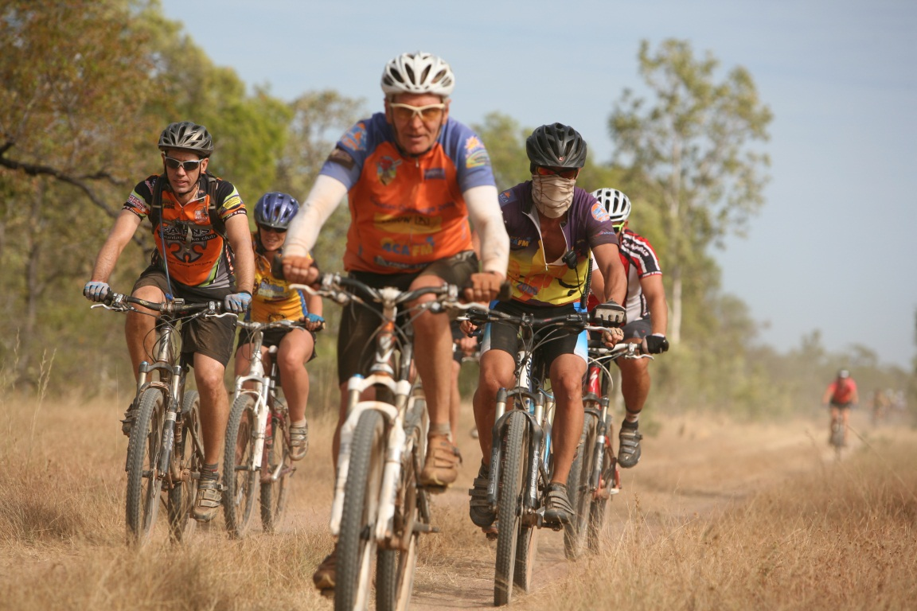

Expression of Interest – 2017 Dirty Boys
Name
Age
Gender
Address
Email address
Phone Number
Are you a member of a bike club? If so, which one?
Describe your experience as a rider (road or dirt, number of years, competitions, club grade level…).
What type of mountain bike are you currently riding?
Please provide a photo of your bike. | (Insert Image Here)
It will be a requirement of all Dirty Boys to have tubeless tyres and have ‘puncture goo’ in your tyres for the ride. Are you able to guarantee that you will adhere to this gear requirement?
Please list the skills and characteristics that you possess that will make you a valuable asset on this ride.
Any other relevant details.

- By completing the above you recognise that this ride requires a level of fitness and cycling expertise beyond that required for the Road Ride.

